**Merge Sort Algorithm**

Merge Sort is one of the most popular [sorting algorithms](https://www.programiz.com/dsa/sorting-algorithm) that is based on the principle of [Divide and Conquer Algorithm](https://www.programiz.com/dsa/divide-and-conquer).

Here, a problem is divided into multiple sub-problems. Each sub-problem is solved individually. Finally, sub-problems are combined to form the final solution.

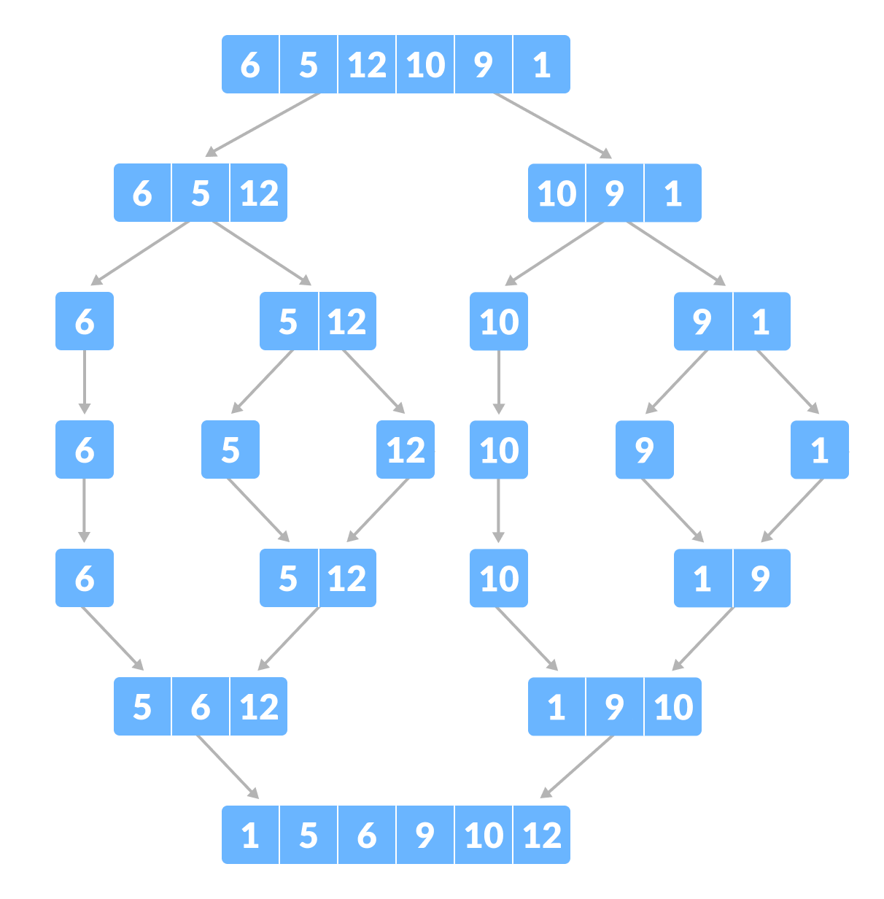Merge Sort example

**Divide and Conquer Strategy**

Using the **Divide and Conquer** technique, we divide a problem into subproblems. When the solution to each subproblem is ready, we 'combine' the results from the subproblems to solve the main problem.

Suppose we had to sort an array A. A subproblem would be to sort a sub-section of this array starting at index p and ending at index r, denoted as A[p..r].

**Divide**

If q is the half-way point between p and r, then we can split the subarray A[p..r] into two arrays A[p..q] and A[q+1, r].

**Conquer**

In the conquer step, we try to sort both the subarrays A[p..q] and A[q+1, r]. If we haven't yet reached the base case, we again divide both these subarrays and try to sort them.

**Combine**

When the conquer step reaches the base step and we get two sorted subarrays A[p..q] and A[q+1, r] for array A[p..r], we combine the results by creating a sorted array A[p..r] from two sorted subarrays A[p..q] and A[q+1, r].

**MergeSort Algorithm**

The MergeSort function repeatedly divides the array into two halves until we reach a stage where we try to perform MergeSort on a subarray of size 1 i.e. p == r.

After that, the merge function comes into play and combines the sorted arrays into larger arrays until the whole array is merged.

MergeSort(A, p, r):

if p > r

return

q = (p+r)/2

mergeSort(A, p, q)

mergeSort(A, q+1, r)

merge(A, p, q, r)

To sort an entire array, we need to call MergeSort(A, 0, length(A)-1).

As shown in the image below, the merge sort algorithm recursively divides the array into halves until we reach the base case of array with 1 element. After that, the merge function picks up the sorted sub-arrays and merges them to gradually sort the entire array.